USE OF ASSET ADMINISTRATION SHELL FOR MONITORING AND CONTROL OF INDUSTRIAL PROCESSES IN LEGACY SYSTEMS

ABSTRACT

The concept of Industry 4.0 brings immediately into question the futility of introducing automation, industrialization, and digitalization, among others, into the many different sectors. This consideration sometimes calls for existing legacy systems to be removed and replaced with those designed to function with these characteristics, which requires resources that, in the case of small and medium-sized enterprises, are extremely scarce in the transition. The paper presents a study on the use of the Asset Administration Shell (AAS) to monitor and control industrial processes employing a Level, Flow, Pressure, and Temperature (NVPT) test bench designed in an era when such legacy systems were manufactured. The study followed the principle of designing system architecture based on the Reference Architectural Model for Industry 4.0 (RAMI 4.0). Implementation of the virtualization proccess lead to the creation of three AAS; two of which were passive AAS responsible for collecting and analyzing data, while the third type AAS was a reactive AAS responsible for controlling the temperature and level of the test bench. Further literature provided engagement modelling approach to the AAS since normal Python did not have built-in support for AAS. The IoT ecosystem package, but with its ssocktio library, provided the asynchronous support needed to builds the two passive AAS while the third reactive type AAS was built using a preemptive approach through the normal usage of Python classes and inheritance principles in data handling. A Raspberry Pi was chosen to execute the use cases to explore the efficacy of Edge Computing, compared the AAS to an enterprise and cloud, by way of more cost and efficient use of resources. This investigation goal led to a functional use case to digitalize the test bench allowing one to monitor and control the test bench variables remotely. In essence, conclusions measured the degree of feasibility and proved the methodology as a viable solution to integrate modern technologies and legacy systems utilizing an economic route. It was concluded that the method had potential to adapt legacy systems to Industry 4.0 environments in economically and efficient manner.

EXISTING SYSTEM:-

The current system employs traditional legacy control systems for industrial processes and does not integrate into modern Industry 4.0 frameworks. Data collection, monitoring, and control are primarily conducted manually or through disconnected systems that do not offer substantial connectivity or automation.

Drawbacks of Current System :

- No automation: Operations are 95% manual, decreasing efficiency and productivity.

- Limited connectivity: Legacy systems do not connect effectively with IoT or cloud systems.
- Utilization of data: There is no visibility to real-time analytics or data-driven actions.
- Costly maintenance: Unnecessary cost increases occur mainly because of constant breakdowns and old components.
- Limited scalability: Current system infrastructure does not have any options to modernize with digital systems.
- Limited visibility: System parameters cannot be reliably viewed and controlled remotely by an operator.

PROPOSED SYSTEM:-

The proposed approach entails incorporating an Asset Administration Shell (AAS) architecture into the RAMI 4.0 model as an upgrade for legacy systems. Through the use of the Internet of Things (IoT), Edge Computing and an AAS model, the system virtualizes industrial assets and enables remote monitoring and controls using a Raspberry Pi-based NVPT test bench.

Advantages of Proposed System

- Increased Automation: Reactive AAS allows for real-time monitoring and control and decreased human involvement.
- Interoperability: AAS allows for safe and seamless communication between legacy systems and an Industry 4.0 type of platform.
- Edge Efficiency: Raspberry Pi allows for a powerful computational capability close to the asset, reducing cloud computing use.
- Scalable Architecture: The proposed system will allow future upgrades with additional sensors or assets.
- Cost Saving Upgrade: The organization will not have to replace the whole legacy system.
- Improved Data Management: Passive AAS modules will help the organization collect data for analytics.

SYSTEM ARCHITECHTURE:-

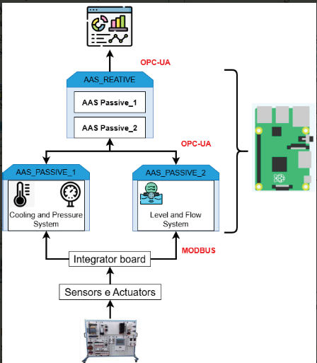

SYSTEM REQUIREMENTS:

HARDWARE REQUIREMENTS:

• System : Pentium IV 2.4 GHz.
• Hard Disk : 40 GB.
• Ram : 512 Mb.

SOFTWARE REQUIREMENTS:

• Operating system : - Windows.
• Coding Language : java.

MODULE DESCRIPTION:-

1. Sensor and Data Acquisition Module

Gathers real-time sensor information for NVPT (Level, Flow, Pressure, Temperature) from the test bench.
Sends the readings to the processing layer over IoT-enabled interfaces.

2. Asset Administration Shell (AAS) Layer

Utilizes digital representations (shells) for each physical asset - two passive AAS related to data analytics, and one reactive AAS used for control.
Ensures standard data models based on RAMI 4.0 principles.

3. Data Processing and Control Module

Uses python scripts to process the sensor values and undertakes appropriate control actions.
Uses asynchronous socket communications with lots of passive AAS's, and preemptive inheritance of the reactive AAS use.

4. Edge Computing Module

Performs real-time processing on Raspberry Pi, thus reducing latency and network load.
Serves as an intermediate hub between IoT devices and cloud/enterprise systems.

5. Cloud and Enterprise Integration Module

Synchronizes data with the cloud server for centralized observations and longer-term patterns.
Provides interoperability between enterprise systems and legacy infrastructure.

6. Monitoring and Visualization Module

Provides a graphical user interface (GUI) to provide remote view of variable and the test bench.
Provides ability for user to change control parameters and view performance trends in real-time capabilities.

Functional Requirements

User Module

- User Authentication

Users will be able to log into the software securely in order to monitor and control the test bench.

- Monitor Test Bench Data

- Monitor real-time values of levels, flows, pressures, and temperatures.
- View historical trends and analytics.

- Control Test Bench Variables

- Control temperature, level, or other parameters that can be controlled via the reactive AAS.
- Once preset limits have been established for any of the variables, the system will alert if the respective variable is exceeded.

- Data Visualization

Basic charts or dashboards will be used for real-time and historical data.

- Export and Reporting

  - The user will be able to download collected data to analyze offline.
  - The user will generate summary reports about system performance.

- Feedback / Notifications

The user will receive notifications or alerts concerning system status, errors, or an action has been fulfilled.

2. Admin Module

- Admin Authentication

Secure access for all administrators.

- User Management

Create, delete or edit users and their entitlements.

- AAS Management

- Set passive and reactive settings for AAS.

- Track which AAS interface has visibility over which variable.

- System Settings

- Control thresholds, sampling intervals, and data storage.

- Maintain and update the system software or AAS logic as required.

- System Monitoring

- Monitor the performance of the Raspberry Pi or edge computing devices.

- Track service and communication failures.

- Data Management

- Backup historical data from test benches.

- Ensure ease of data integration for edge computing, enterprise and cloud applications.

